Surrey County Chess Association
a company limited by guarantee not having a share capital
company registration number 5602632
registered office 38 Glebe Road, Ashtead, Surrey KT21

Minutes of Annual General Meeting

20 June 2021

Virtual meeting using Zoom from 2.00 pm.
Paul Shepherd (President) was in the Chair.
Attendees

Nominated Members entitled to vote:
Ashtead: Dan Rosen, Richard Jones (also proxy for Bertie Barlow)
Dorking: Peter Lawrence (also proxy for Brian Skinner), Brian Skinner
Crystal Place Chris Bernard (also proxy for David Hodgson, Mark O’Neill)
Epsom: Marcus Gosling, Michael Wickham, David Flewellen
Guildford: Mike Gunn (also proxy for Trevor Jones), Phil Stimpson

Kingston: Nick Grey, Alan Scrimgour

Richmond: Huw Williams
South Norwood: David Howes (also proxy for Ken Chamberlain, Simon Lea, Martin Cath)
Streatham: Richard Tillett
Surbiton: Paul Durrant (also proxy for David Morant, Steven Kearney, Malcolm Groom)
Wallington: Daniel Young
Wimbledon: Gordon Rennie
Attendee entitled to a casting vote: Paul Shepherd (Chairman)
Attendees not entitled to vote: Clive Frostick (Farnham & Guildford), Paul Dupre (South Norwood), Nick Faulks (Surbiton)

Paul Shepherd provided advice about the use of Zoom during the meeting including how to show a hand-vote and mute/unmute.

In memoriam

Respects were paid to John Davis (Dorking) and Mike Bolan (Ashtead)

2. Annual Finance Meeting 2020 (resumption)

1) The chair opened this meeting which was adjourned on 27 August 2020.

2) Apologies for absence

Martin Smith, David Sedgwick, Paul Dunican and Trevor Jones

3) Proposal by the Board to make no charges for the 2020/21 season.

The purpose of the meeting was to waive charges for the 2020/21 season. Online chess had been provided without charge. Dan Rosen confirmed that although there were a couple of charges, they will be billed for the 2021/22 season so there will be no charges for this season. The proposal was passed nem.con.

4) Any Other Business

None

3. Annual League Composition Meeting 2020 (resumption)

1) The chair opened this meeting which was adjourned on 27 August 2020.

2) Apologies for absence

Martin Smith, David Sedgwick, Paul Dunican and Trevor Jones

3) Proposal by the Board to accept team entries to the Main League for the 2020/21 season identical to those accepted for the 2019/20 season.

This is a proposal by the Board to accept team entries to the Main League for the 2020/21 season identical to those accepted for the 2019/20 season. Paul Shepherd explained that the main purpose of the meeting was to avoid each club only having 1 vote. Apart from the fact that would be inequitable it would also carry the risk that there might not be a quorum. Essentially this measure would mean that club voting rights for the 2019/20 would be carried over to the 2020/21 season. The proposal was passed nem.con.

4) Any Other Business

None

Annual General Meeting 2021

1. Apologies for absence

Martin Smith, David Sedgwick, Paul Dunican and Trevor Jones

2. To approve the following Minutes:

(a) Annual General Meeting of the Company held on 28 June 2020.

The Minutes were approved.

(b) Extraordinary General Meeting of the Company held on 27 August 2020.

The minutes were approved.

3. Matters Arising

None

4. Questions about Directors’ Reports

Details of the written reports were distributed prior to the meeting and only written questions submitted in advance of the meeting will be permitted.

a) President: None

b) Deputy President: None

c) Administrative Director: None

d) Inter-Club Tournaments Director: None

e) Non-Executive Directors: No Report and no questions

5. Treasurer’s Report and Approval of Accounts for the Year Ended 30 April 2021.

Copies of the Accounts for the year ended 30 April 2021 had been provided. Dan Rosen advised that the accounts differ from previous seasons because there had been no income and very little expense. The recharges to clubs for 2019/20 which would normally have been invoiced in October 2020, but would be included in club invoices in 2021/22. The expenses relate to insurance, ECF recharges and the website. There is a core expenditure of about £700 could not be avoided. There was no charge for the online competitions. The Surrey Chess Congress has been wound up and a sum therefrom of £420 transferred into the SCCA Accounts. Essentially the SCCA can afford a bad year.

There were no comments.

The accounts were approved nem.con.

6. Questions about Officers’ Reports

a) ECF Delegate: None

b) SCCU Representative: None

c) Company Secretary: None. Richard Jones advised that if the new Non-Executive Director is elected his details will need to be filed at Companies House.

d) County Team Captains: Mike Gunn reported that it had been very difficult to raise full teams for the ECF county match online competitions. There was a total of 24 boards over 2 teams and it had hardly ever been possible to field full teams.

(e) Junior Team Managers: None.

(f) Individual Tournaments Secretary: Nothing to report.
(g) Correspondence Chess Secretary: None. Paul Shepherd expressed thanks to all who were involved in running or organising the online competitions including county chess, league chess, individual tournaments as well as the correspondence chess
h) Grading Officer: None
i) Webmasters: None

(j) Curator of Equipment. None.

(k) Curator of Trophies: None.

(l) Chairman of the Chess Disputes Committee: None

m) County Match Secretary: None.

7. Report Surrey Chess Congress

Mike Gunn thanked the Board for being willing to continue with the SCC when they can. He also took the opportunity to provide information about a simultaneous event to be staged by Guildford Chess Club on 11 September in Guildford High Street. Paul Shepherd thanked Guildford for being willing to stage such an event and requested Mike Gunn that if he had any further documentation in respect of the Surrey Chess Congress Company to pass it on to the SCCA.

8. Election of Directors

The existing Directors are:
President – Paul Shepherd
Deputy President – Alan Scrimgour
Administrative Director - Peter Lawrence
Treasurer – Dan Rosen
Inter-Club Tournaments Director – Huw Williams
Non-Executive Directors – Clive Frostick and David Flewellen

Paul Shepherd informed the meeting that during the year Russell Granat had resigned as the Deputy President and had been replaced in that role by Alan Scrimgour. That had created a Non-Executive Director vacancy which the Board has filled by appointing David Flewellen. Information prepared by David about his candidature had been provided to the attendees prior to the meeting. There were no questions in respect thereof.

All of the existing directors were willing to stand for re-election and there were no other candidates.

A vote to re-elect the existing directors en bloc was passed nem.con. They were duly re-elected.

9. Election of Independent Examiner

A motion supporting the reappointment of Richard Jones was passed nem.con.

10. Resumption of OTB Chess

Paul Shepherd advised the meeting that he had prepared a set of slides which he would run through and then take question afterwards. This was done and the questions and answers following the presentation are shown below. See Appendix A for details of the presentation. Paul stressed the fact that any offering of online chess is complementary to but not competing with OTB chess which is of vital importance to clubs. There will be a modest charge for online chess in future and it will be on a friendly unrated basis using the Tornelo platform.

Dan Rosen indicated that Ashtead is reconsidering its decision about whether to play the outstanding fixtures from the 2019/20 season and will respond before 30 July. He also thought that come September and in respect of the finals of the cup competitions Ashtead may be able to be a neutral venue should the need arise.

Phil Stimpson enquired whether Guildford should give priority to cup matches in preference to league fixtures?

Paul Shepherd replied that aspect will be addressed when the fixtures are drawn up. Phil then drew attention to the possibility that the club venues may impose restrictions. Paul said that he could not second guess what these restrictions might be and this was really outside the remit of the SCCA. What he hoped was that clubs will be respectful to one another and try to comply with venue requirements. Phil then enquired what should clubs do in respect of ECF recommendations concerning COVID-19 precautions. Paul replied that he would need to confer with the Board but his initial thoughts are that the advice from the ECF was just that and is not mandatory. Clubs do not have to comply with recommendations and we are currently in stage 3. When the government moves to stage 4 there may be further relaxation. The Board will provide further advice if there is a need to do so.

David Howes thought that captains involved in playing off matches for the 2019/20 should be reminded that it is the 2019/20 ratings that should apply. This was confirmed and also that the August 2021 ratings will apply to the new season.

Brian Skinner enquired whether the nominations for 2019/20 should apply to the unfinished seasons matches. Dan Rosen confirmed that they should. Brian also asked when it is likely that they new season will start. Paul Shepherd replied that it would depend on the number of clubs wishing to play their unfinished matches but it should be clear by 30 July when the entries have been received and the fixtures for the completion of the 2019/20 season can be drawn up. It may be necessary to start the new season later.

Mike Gunn enquired how should they deal with new players who had no ECF rating but did have online ratings from the platforms. He did not place a lot of reliance on platform ratings and thought that a better guide would be the results that those players had against ECF rated players. Paul Shepherd and Dan Rosen indicated that the Controller will be able in those circumstance to provide an estimated rating. Huw Williams confirmed that he will work with Brian Skinner in that respect and pointed out that if the estimated rating needs to be changed as results are reported then it will be amended.

Peter Lawrence mentioned that if there is a late start to the new season then the playing season might need to be extended until 31 May.

Paul Dupre stated that he had an extensive database of players results and would be happy to provide help in respect of estimated ratings.

Richard Tillett is concerned about the potential disparity between venues in respect of COVID-19 requirements. He thought that clubs must make their venue requirements clear to visiting teams. He gave as an example the differing precautions required between Wandsworth and Lambeth Councils. Paul Shepherd thanked him for raising the point and it would be given further thought. Brian Skinner advised that if clubs provide information about their venue COVID-19 precautions they can be posted under the club page on the SCCA website.

Richard Jones asked what would happen if a team turned up at the opposing club venue and one of their players said that the venue was unsafe in respect of COVID-19 precautions. Paul Shepherd explained that if the home venue complied with the law, then any visiting player refusing to play would be defaulted. The SCCA could not provide specific advice about what precautions were necessary for individual venues.

Nick Grey said that he hoped the run off matches for the 2019/20 season could be started as soon as possible.

Mike Wickham asked whether the Board needed greater powers to deal with unexpected situations in order to avoid the need to call EGM’s. As an example, suppose the ECF recommended the use of face masks, the situation could arise where some players expected face masks to be worn and may find their opponent not wearing one. Dan Rosen responded that if the measure was a legal requirement, then both players have to comply but if it is just a recommendation then there is no compulsion and a refusal to play would result in a default as previously advised. Paul Shepherd stated that the Board would be give this matter further consideration. Alan Scrimgour agreed with what Dan had said and pointed out that without knowing what the problem is how could the Board know what extra powers they needed.

Paul Shepherd then displayed some of the relevant slides from his presentation about how the SCCA propose to complete the 2019/20 season and asked for a show of hands for those in favour. There were none against so the proposed measures were approved nem.con.

Paul Shepherd then displayed the slide headed Online Competitions beyond OTB restart. He went through the various key points but stressed the importance that online chess must not undermine OTB chess otherwise it may be a struggle for some chess clubs to exist.

Huw Williams then provided further comments about online chess stressing that the most important objective that he had is the successful return of OTB chess. However, at the appropriate time an online offering can be provided using the Tornelo platform that had been used in Surrey Friendly Online Competitions

to date. There may be further government restrictions in the future and it may be that the online offering may need to be increased but for now the important challenge is the return of OTB chess. The games will be unrated but there is anti-cheat software running in the background but it had not been applied. Huw had examined the background information and it was clear that the higher rated players were making better moves and he concluded in consequence that there had been no evidence of any cheating.

Brian Skinner enquired whether Wednesdays for the online competitions was sacrosanct? Would not a Friday evening be better when clubs do not have OTB chess? Huw Williams explained that Friday evenings were his family night and that Wednesday evening was the most suitable night for online chess. Only Wallington may play on a Wednesday evening as Surbiton are moving to a new venue and it is unlikely, they will play on a Wednesday in future.

Paul Durrant asked for a delay in providing online chess so that OTB chess is firmly underway first. This is vital for the clubs.

Daniel Young confirmed that Wallington Chess Club do meet on Wednesday’s evenings but they already have their own online offerings and are unlikely to take part in any Surrey online competitions.

Gordon Rennie advised that Wimbledon are normally involved in playing London League chess on a Wednesday evening and assuming the London League does continue it is unlikely that Wimbledon players will take part in any Surrey online offerings.

Chris Bernard explained that some Crystal Palace members were also members of Streatham Chess Club and usually played online with Streatham. It is therefore unlikely that Crystal Palace will field an online team.

Richard Tillett mentioned that Streatham also entered teams in the London League playing on a Wednesday evening so it is unlikely that they will enter a team in any Surrey online competitions.

Dan Rosen thought that Wednesdays were probably the best night for online chess but it would just have to be accepted that not every club could take part. He did however agree with Paul Durrant that there should be a delay to the start of online chess so that OTB chess is well underway first.

Alan Scrimgour agreed to a delay in starting online chess but thought that it was good that when it does start it will focus on blitz and rapidplay. That is likely to be attractive to younger players.

2 straw polls were conducted:

a) How many clubs support a break before there is an online competition? – There was essentially unaminous support.

b) How many clubs think they will field an online team? – 7 which equals about 40%.

Dan Rosen said that if there is say a 6 month delay in starting the online competition and also a delay in sending out the entry form how can he provide an estimate for the income in the Budget? Paul Shepherd responded that would be dealt with separately by the Board.

Phil Stimpson suggested that for future years the online competitions could be run in the dead space before or after the OTB competitions are played.

Nick Faulks hoped that Huw Williams would not feel rebuffed by the lack of interest in online chess and thanked him for providing the online competitions in which he had enjoyed playing.

11. Any Other Business

None

The meeting closed at 16.27.

Appendix A

SCCA AGM 2021
OTB Restart Consultation

Club | OTB from 6  September? | Wish to complete unfinished  fixtures 19-20? | Other comments
Ashtead | Don’t know | No | OTB restart subject to  members return
Battersea |  | N/A
CCF | Yes | Yes
Chessington |  | N/A
Crystal Palace | Don’t know | No | Subject to club continuing
Dorking | Yes | Not Ellam or Minor Trophy.  Just Stoneleigh Trophy. | Subject to COVID-19
Epsom | Yes | Yes | 2021-22 divisional structure may need revising
Guildford | Yes | Yes | Subject to COVID-19
Kingston | Yes | No
Redhill | 1 October | Yes | Potential issue if COVID-19 protocols vary between clubs
Richmond | Yes | Yes | Need to be flexible if  COVID-19 changes things
S Norwood | Yes | Yes
Streatham | Don’t know | No | Cannot yet engage with venue holder. Believe 19-20  should be abandoned
Surbiton | Yes | All except Surbiton 1 and 3  fixtures | Lost some team captains
Wallington | Don’t know | Already completed | Restart depends on venue
Walton on the Hill | No | N/A | Will not go OTB
Wimbledon | Yes | No | Lost too many players to  finish 19-20
Woking |  | N/A

Summary of Clubs’ Feedback

- All of this is subject to the COVID-19 regulations allowing OTB team match chess to restart again
- 6 September was chosen to allow the completion of 2019-2020 season before the new 2021-2022 season
  - Nine clubs ok
  - Four don’t know (subject to venue, member return or club survival)
  - Walton on the Hill has elected to not play OTB
  - Redhill restart 1 Oct
- Of those who wish to complete their 2019-2020 fixtures only Redhill (one fixture) can’t do 6 September
  - Eight clubs wish to complete the season
  - Five do not
  - Battersea and Wallington already completed
- 6 September therefore seems like a reasonable planning basis for the start of 2019-2020 completion

Conditions for the OTB restart

- It must be legal to hold gatherings inside, up to the numbers involved in chess matches/clubs
  - This requires the UK to move from Stage 3 to Stage 4 so that the “rule of six” indoors no longer applies
    - As of 14 June this is now projected to occur on 19 July
  - The progress of the government response to the pandemic will continue to be monitored

- The Board is not minded to impose any additional conditions on clubs for OTB SCCA chess competitions than are required by UK law

- A majority of clubs wish to complete their 2019-2020 fixtures
- The break in the season has been the same for everyone
  - It is a difficult playing field but it is a level one
- The season was 70-80+% complete in all divisions when it was suspended
- Those who wish to complete matches and compete for trophies should not be prevented from doing so
- The following approach, that appears most equitable in the circumstances is proposed:
  - Where two clubs wish to complete a fixture they play it out
  - Where neither club wishes to complete a fixture the match is declared void and scored 0-0 in terms of game and match points
  - Where one club wishes to complete a fixture against a club that does not wish to then the club wishing to complete is awarded a X-0 match win (where X is the number of Boards)
o Recognising the exceptional circumstances it is proposed to not apply any further penalties
- All outstanding 2019-2020 matches will be quickplay finish
- The 2021-2022 season will not be started until the 2019-2020 season is ended to manage the admin burden on the webmasters running the results system

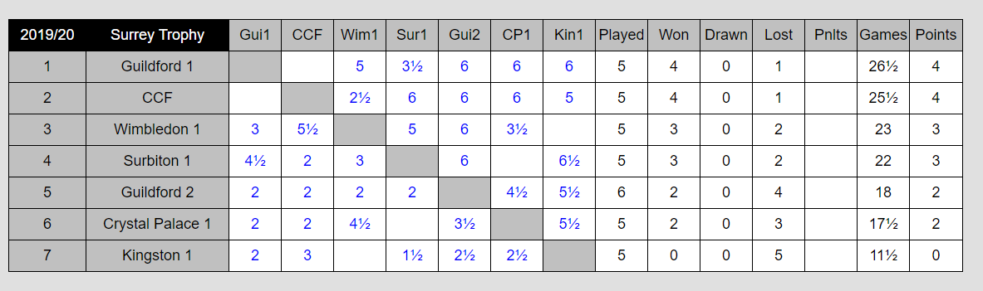

- Guildford 1 vs CCF will decide the trophy winners
- No other matches are possible

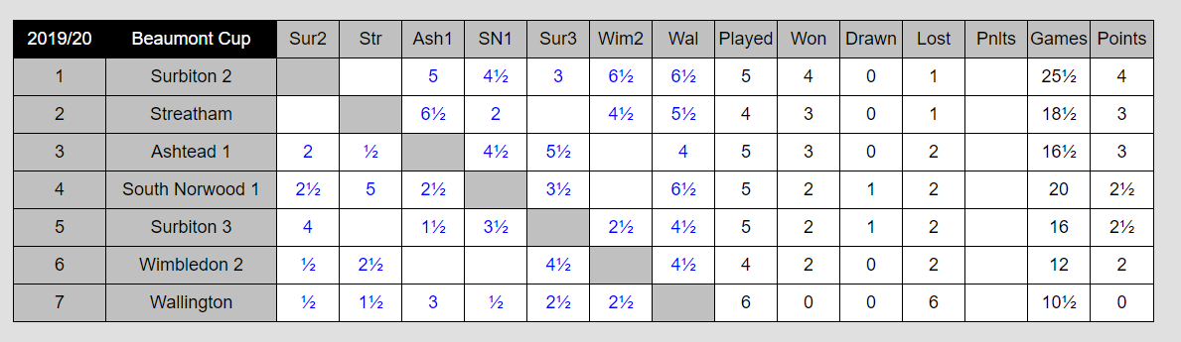

- Surbiton 2 would win the Beaumont Cup
- South Norwood 1 also wishes to complete
- However no further matches are possible

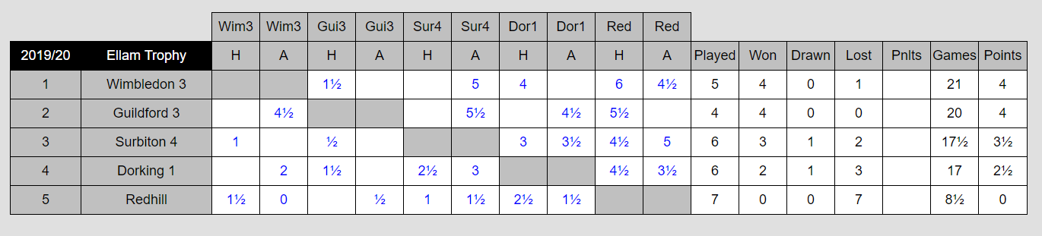

- Guildford 3 would win the Ellam Trophy
- Guildford 3 vs Surbiton 4 and Redhill vs Guildford 3 could be played
  - However those fixtures would not impact the title

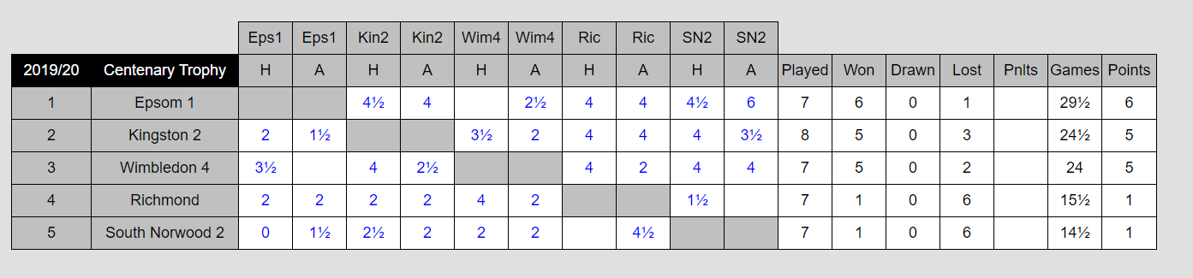

    - Epsom 1 would win the Centenary Trophy
    - South Norwood 2 vs Richmond can be played
      - However that fixture would not impact the title

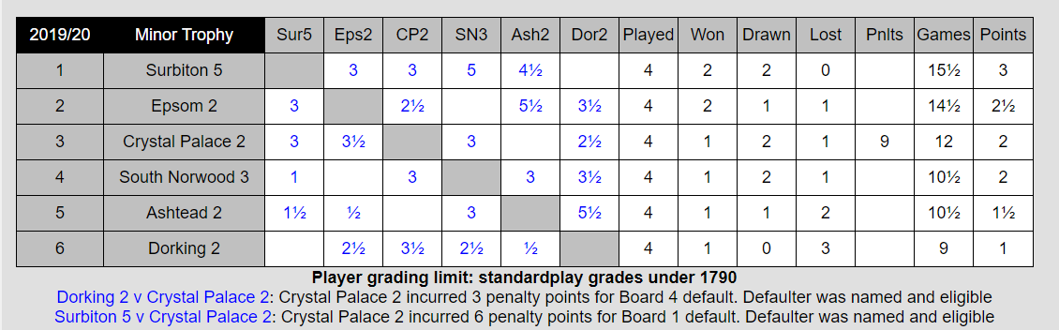

    - Surbiton 5 would win the Minor Trophy
    - South Norwood 3 vs Epsom 2 can be played
      - However that fixture would not impact the title

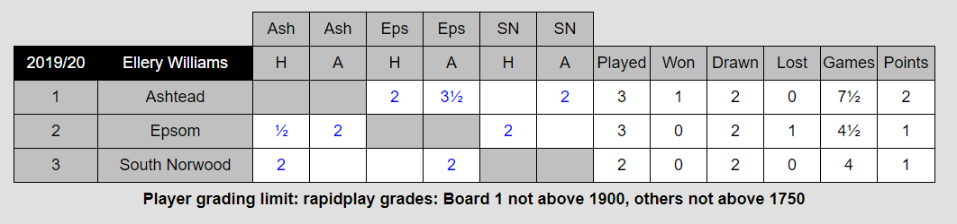

- South Norwood vs Epsom would decide the trophy winners
- Other match not possible

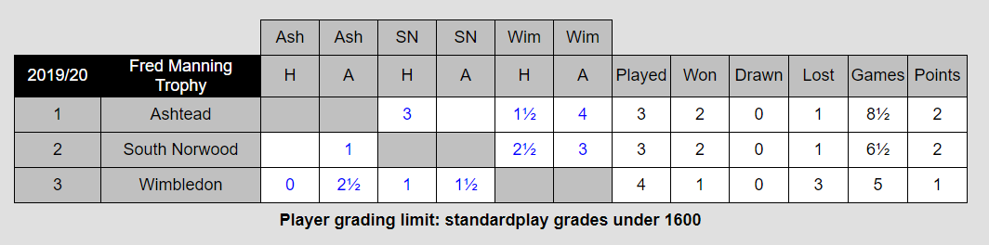

- South Norwood would win the Fred Manning Trophy

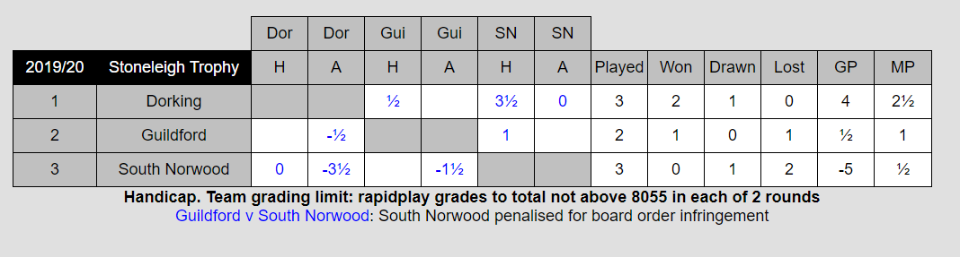

- The two remaining matches will decide the trophy winners

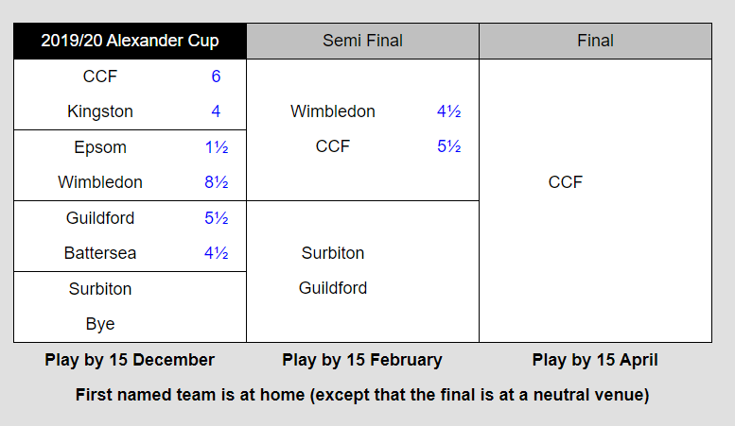

  - The two remaining matches will decide the trophy winners

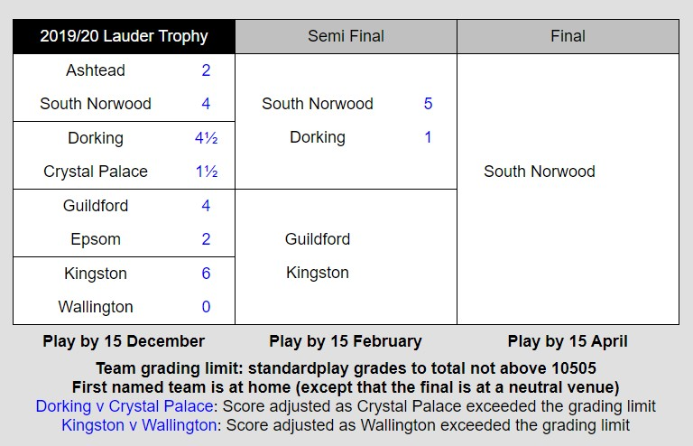

- The final would be between South Norwood and Guildford

Unfinished Competitions - Summary
- In light of the clubs’ stated preferences to complete or not and applying the proposed
approach to scoring unfinished matches the consequences would be:
  - Five trophy winners would be decided
    - In most cases the winner would have the highest match points vs games played percentage when the season was suspended
    - This is not totally satisfactory but it is better than abandoning those competitions
  - Seven matches would decide the remaining five trophies
  - A further four matches could be played but they would not influence the trophies
    - Are they worth playing?

- It should be possible to play the crucial matches in September
  - Guildford’s ability to field multiple teams is going to be the key determinant

- Please ensure club officials changes, including captains, are notified to SCCA in good time

- Some clubs may wish to reconsider their initial positions of not wanting to complete
  - This can be done on a team by team basis
  - Final decision required 30 July

- This is now the moment to confirm or otherwise alignment with this plan

Online Competitions beyond OTB restart

The Board are very conscious of not wanting to undermine our clubs’ efforts to entice their members back into a face to face OTB situation as their survival will depend upon the success or otherwise of achieving that return
- However we are willing to consider looking at an ongoing online offering that is complementary, not competing, with SCCA OTB competitions
- Initial thoughts
  - Wednesday evenings
  - Fortnightly (or monthly) Blitz or Rapidplay
  - Rapidplay 15 min + 10 secs, teams of three, three rounds per night
  - Blitz 7 min + 2 secs is an alternative
  - Friendly event, Tornelo platform, ungraded

Participant clubs must be Members of the SCCA
- Team entry fees set at 40% of OTB rate
- Reactions? Interest?

